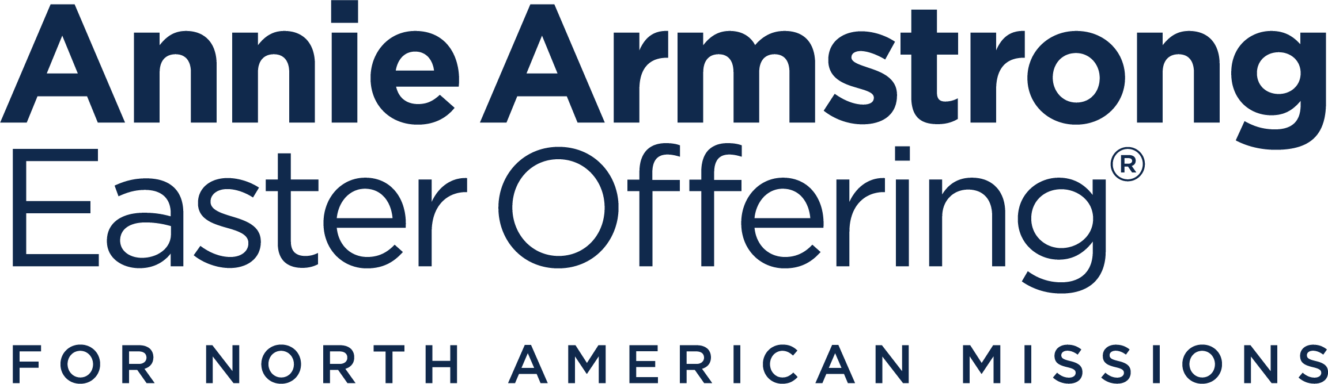

AAEO Overview
Title: Annie Armstrong—More Than a Gift

2026 Annie Armstrong Easter Offering
- National Goal: $80 million
- Week of Prayer for North American Missions: Sunday, March 1 through Sunday, March 8
- Theme: More Than a Gift
- Theme Verse: “Now to him who is able to do above and beyond all that we ask or think according to the power that works in us—to him be the glory in the church and in Christ Jesus to all generations, forever and ever. Amen.” Ephesians 3:20-21, CSB
- Resources Available: AnnieArmstrong.com
- Week of Prayer Featured Stories
- Sunday, March 1: Collegiate church planting missionary sees God do “more than we could’ve have ever imagined”, West Lafayette, Indiana
- Monday, March 2: From addiction to redemption: Virginia missionary’s recovery ministry leads to new church, Tappahannock, Virginia
- Tuesday, March 3: New believer finds recovery and his calling through a church plant and a mentor who knew the same road, Tappahannock, Virginia
- Wednesday, March 4: Reaching Montreal: Church plant led by former Muslim bringing gospel to unreached city, Montreal, Quebec
- Thursday, March 5: God’s Not Done Here: Church planter blends old with new to bring renewal to New Orleans neighborhood, Marrero, Louisiana
- Friday, March 6: Story of church replant includes uniting local couple in faith and marriage, Marrero, Louisiana
- Saturday, March 7: Compassion ministry helps church planting missionary family “go big” in Puerto Rico, Rio Grande, Puerto Rico
- Sunday, March 8: NAMB Missionaries experience Generosity: How the Annie Offering Is More Than a Gift

- Media Contact: For information or interview requests with NAMB’s Week of Prayer missionaries, contact media@namb.net.

Overview

The lost live among us.
There are roughly 291 million of them—they are friends and family, neighbors and strangers. They speak 378 different languages. Some of them even belong to the 161 unreached people groups who’ve come to live in the U.S. and Canada.
It’s now estimated that more than two out of every three people in North America are lost, and that number is growing larger every day. Even in areas where gospel presence was once strong, the need for missionaries and new churches is increasing.
In our own neighborhoods, towns, and cities, the need for the gospel is historically great—but God is greater.
He takes the faithful prayers and generous giving of Southern Baptists to the Annie Armstrong Easter Offering® and fuels the work of thousands of missionaries, sending them all over the U.S. and Canada to plant churches and meet the needs of people who’ve not yet had the opportunity to hear and respond to a gospel witness.
Since 2010, Southern Baptists have planted more than 11,000 churches across North America. In 2024, we came together to add 767 church plants to the Southern Baptist Convention (SBC). If we continue planting new congregations at this rate, by 2030, one-third of the SBC will consist of churches planted since 2010.
Last year, Southern Baptists united to give $71.1 million to the Annie Armstrong offering, and every dollar of that offering went straight to the mission field. This year's national goal is $80 million. Reaching and even exceeding that goal will mean we can support those currently serving and send out even more missionaries to share Christ with more people all over North America.
There is, then, no such thing as just a prayer or a tiny gift because God promises to do above and beyond all that we ask or think. That means when we are faithful to pray and give, we can do so with great expectations, knowing He will use us all to produce kingdom-sized results far beyond what anyone can imagine.

