APPENDIX B: SUGGESTED EMAIL PROMO CONTENT

PROMO EMAIL TEMPLATE #1

[Subject Line:] You’re invited to Send Network One Day in [City]
[Preview Text:] Be part of a powerful event in [City] as we pray, worship, and strategize to multiply disciples and churches.

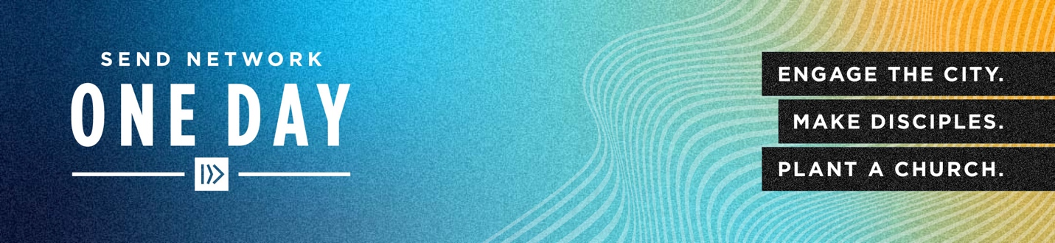
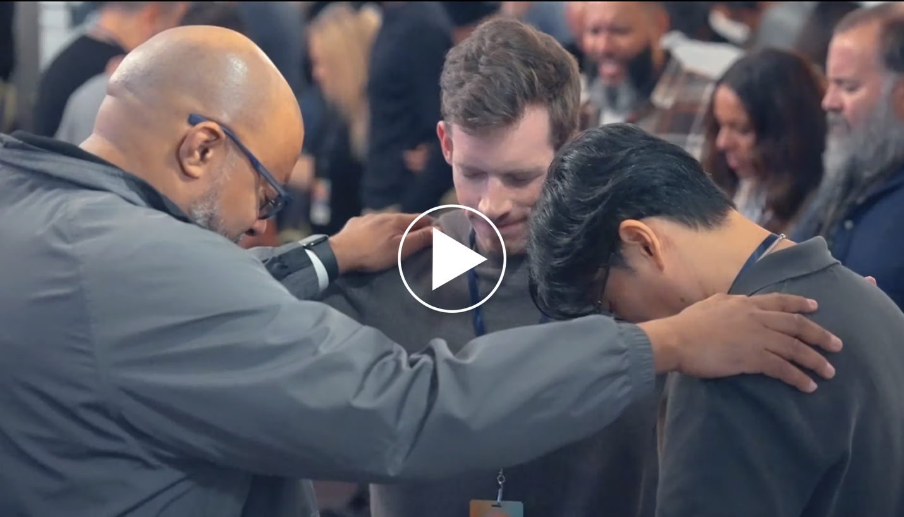
[Link image to sendnetwork.com/oneday or your location's event page]

Hi [First Name],

Exciting things are happening through Send Network, and we want you to be part of it! A Send Network One Day is coming to [City, State] —a local, one-day event designed to bring churches and believers together to advance God’s mission.

This year, we are gathering to celebrate what God has done and look forward to the “exceedingly abundantly more” He will do. We are locking arms to engage cities with the gospel, make disciples, and join God in His work to plant thousands of churches.

This is an opportunity to:
• Pray together and seek God’s direction.
• Worship as a unified body.
• Learn from experienced leaders and planters.
• Strategize to reach our cities with the gospel.

📍 Location: [Venue Name]
📅 Date: [Event Date]
📌 Address: [Venue Address]

Come expectant and bring someone with you — whether a leader, team member, or someone exploring their role in
God’s kingdom.

Register today at SendNetwork.com/oneday! [button]

We can’t wait to see what God will do when we come together!

In Christ,
[local field leader name + signature]

_____________________________________________________________________________________________

PROMO EMAIL TEMPLATE #2

[Subject Line:] [City], Let’s Come Together for Send Network One Day!
[Preview Text:] A local event for prayer, worship, and strategy — join us for A Send Network One Day in [City].

[Link image to sendnetwork.com/oneday or your location's event page]
Hi [First Name],
Imagine what God can do when His people unite around His mission. Send Network One Day is coming to [City, State], and we want to invite you to be part of this special event!

At this local event, believers from across [region/area] will come together for:
• Prayer that fuels our passion for the Great Commission.
• Worship that strengthens our faith and calling.
• Encouragement from church planters and pastors on the front lines.
• Collaboration on how we can engage the city, make disciples, and plant a church.

📍 Location: [Venue Name]
📅 Date: [Event Date]
📌 Address: [Venue Address]

Bring your spouse, church staff, members of your core team, a ministry partner, or someone exploring church planting in any capacity. This is a day to be inspired, equipped, and sent!

Register for Send Network One Day in [city name] [button]

We can’t wait to see what God will do when we come together!

In Christ,
[local field leader name + signature]

_____________________________________________________________________________________________

PROMO EMAIL TEMPLATE #3

[Subject Line]: Don’t Miss Send Network One Day in [City]!
[Preview Text]: Seats are filling up! Join us for a powerful day of worship, strategy, and vision at Send Network One Day in [City].

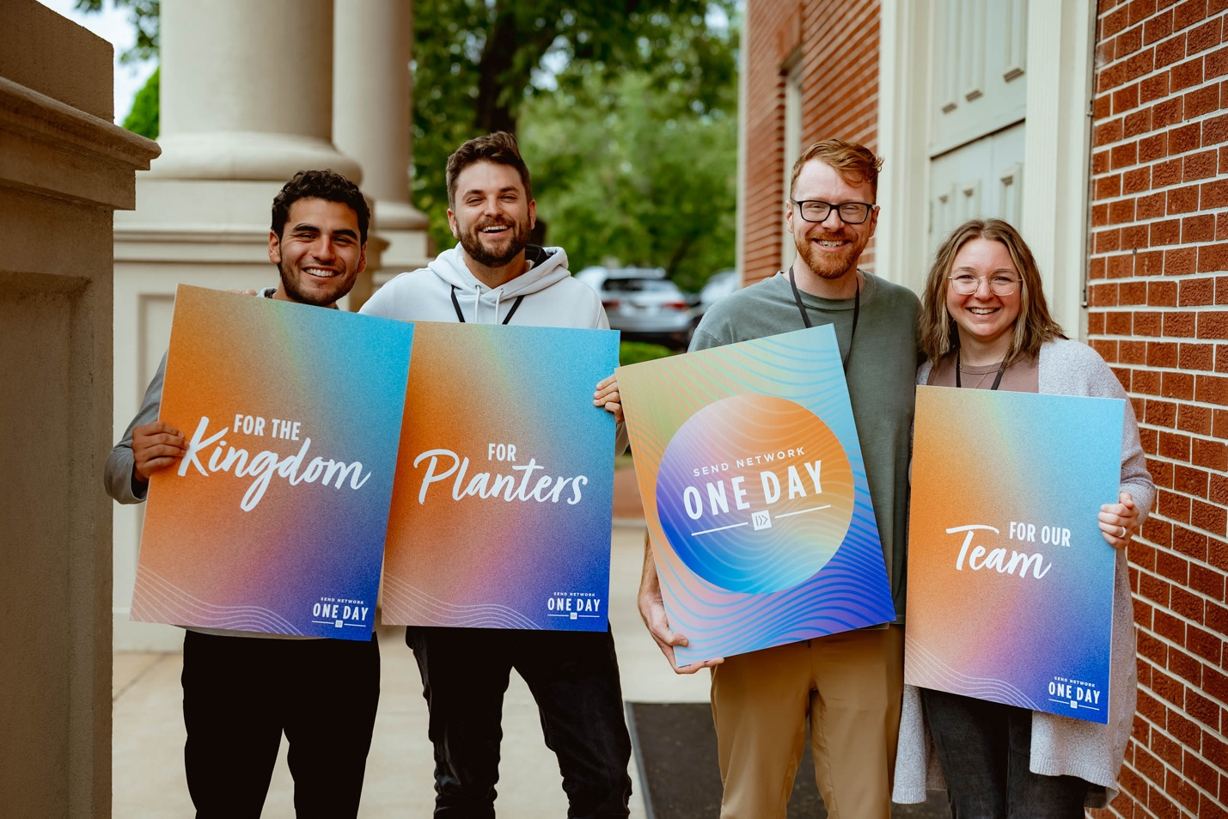
[Link image to sendnetwork.com/oneday or your location's event page]

Hi [First Name],

Send Network One Day is coming to [City, State], and there’s a place for you in the church planting movement! This is a one-day, local event focused on prayer, vision, and strategy to see God’s kingdom expand in our communities.

Here’s what you can expect:
• A day of prayer, worship, and inspiration.
• Practical tools to help multiply disciples and churches.
• Connections with others passionate about advancing the gospel.

📍 Location: [Venue Name]
📅 Date: [Event Date]
📌 Address: [Venue Address]

Space is limited, so register today and forward this email to a friend who needs to come with you!
Register for a day of encouragement and renewed vision [button]

We can’t wait to see what God will do when we come together!

In Christ,
[local field leader name + signature]
_____________________________________________________________________________________________

“KNOW BEFORE YOU GO” EMAIL TEMPLATE #1 (send approximately 2 weeks out to registrants)

[Subject Line]: Get Ready to join in on Send Network One Day in [city]!
[Preview Text]: Here’s everything you need to know before the big day.
[Link image to sendnetwork.com/oneday or your location's event page]

Hey [First Name],

Thank you for registering for Send Network One Day in [city]! We’re excited to join you for an inspiring and transformative day of worship, prayer, learning, and strategizing to reach the lost in North America. Here’s some vital info to make sure you’re fully prepared:

Your Event Details:
• Date: [Month ##, 2026]
• Address: [## Street Name, City, State Zip Code]

Parking:
We’ve made parking easy! [Insert parking details or instructions, if applicable].

Event Schedule:
[Example schedule and formatting. Insert your own. Be sure to note that lunch is provided]
• 9:00 AM – Registration & Coffee
• 9:30 AM – Welcome & Worship
• 10:30 AM – Speaker Name 1
• 11:15: AM – Speaker Name 2
• 12:00 PM – Lunch (provided)
• 1:00 PM – Breakout Sessions & Strategy Planning
• 3:00 PM – Closing Remarks & Prayer

Be one of the first 200 attendees to check-in and you’ll receive a free t-shirt!

If you have any questions before the event, feel free to reach out to us at [email]. We can’t wait to see you there for an impactful day!

Blessings,
[Field Leader Name]

__________________________________________________________________________________

“KNOW BEFORE YOU GO” EMAIL TEMPLATE #2 (send 1-2 days before the event to registrants)

[Subject Line]: Only [##] days before Send Network One Day in [City]
[Preview Text]: Get ready to hear from incredible leaders and experience an unforgettable day together
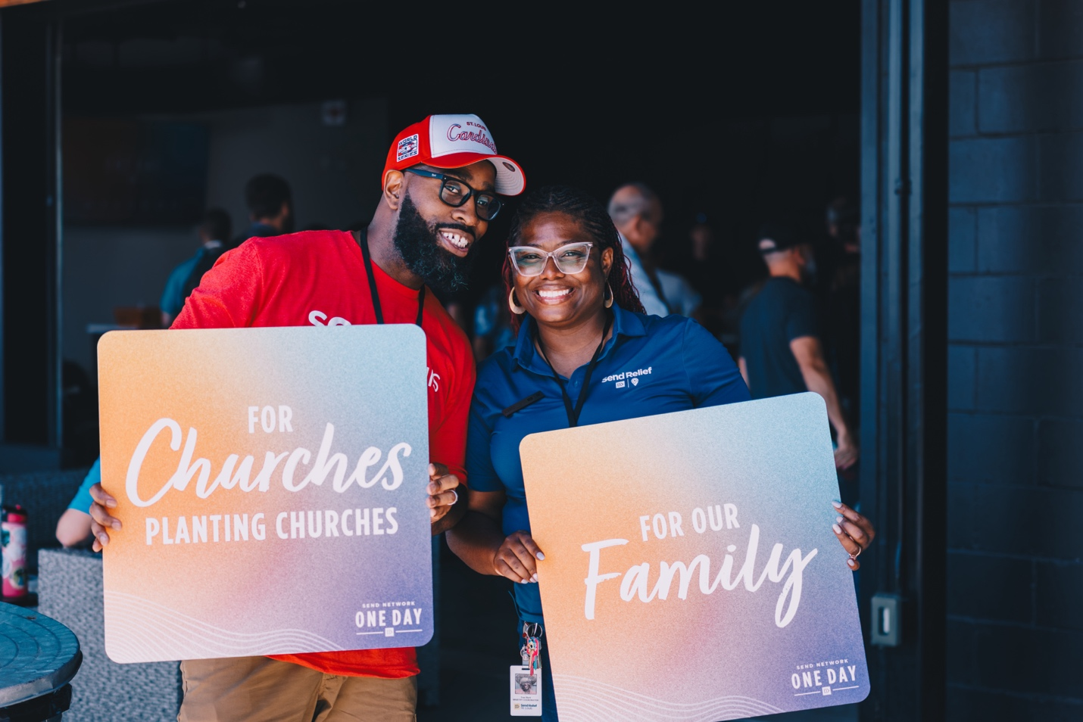
[Link image to sendnetwork.com/oneday or your location's event page]

Hey [First Name],

Thank you for registering for Send Network One Day in [City]! We’re looking forward to spending an inspiring and transformative day with you, focused on what God is doing in North America and the role we all have in seeing His mission expanded.

At this event, you’ll hear from some of the most influential leaders in the church planting movement in our city.
These speakers are passionate about equipping and empowering believers to boldly take part in the mission to reach 1% of the lost in North America. You won’t want to miss the insights, stories, and strategies they’ll share that will help you, your church, and your community step into God’s mission.

Here’s some key information to make sure you’re fully prepared for the event:

Your Event Details:
[Example event details and formatting. Insert your own. Be sure to note that lunch is provided]

Address: [## Street Name, City, State Zip Code]

Date: [Month ##, 2026]

Schedule:
• 9:00 AM – Registration & Coffee
• 9:30 AM – Welcome & Worship
• 10:30 AM – Title of Session: Speaker Name 1
• 11:15: AM – Title of Session: Speaker Name 2
• 12:00 PM – Lunch (provided)
• 1:00 PM – Breakout Sessions & Strategy Planning
• 3:00 PM – Closing Remarks & Prayer

We’ve made parking easy! [Insert parking details or instructions, if applicable].
Be one of the first 200 attendees to check-in and you’ll receive a free t-shirt! Lunch is provided, so come ready to connect, collaborate, and grow with other Jesus followers who share your heart for God’s kingdom.

For any questions before the big day, feel free to reach out to us at [email].

We can’t wait to see you there!

Blessings,
[Field Leader Name]

